**TEAMID: PNT2022TMID45483**

Assignment4:

Write code and connections in wokwi for the ultrasonic sensor. Whenever thedistanceislessthan100cmssendan "alert" totheIBMcloudanddisplayinthedevicerecent events.

Program

//PinsconstintTRIG_PIN=7; constintECHO_PIN=8;

//Anythingover400cm(23200uspulse)is"outofrange"constunsignedintMAX_DIST=23200;

voidsetup(){

//The Trigger pin willtellthe sensor to range findpinMode(TRIG_PIN,OUTPUT);

digitalWrite(TRIG_PIN,LOW);

//SetEchopinasinputtomeasurethedurationof

//pulsescomingbackfromthedistancesensorpinMode(ECHO_PIN,INPUT);

//We'llusetheserialmonitortoviewthesensoroutput

**Serial**.begin(9600);

}

void loop(){unsignedlongt1; unsignedlongt2;

unsignedlongpulse_width;float cm;

floatinches;

// Hold the trigger pin high for at least 10 usdigitalWrite(TRIG_PIN,HIGH);delayMicroseconds(10); digitalWrite(TRIG_PIN,LOW);

//Waitforpulseonechopin while(digitalRead(ECHO_PIN)==0);

//Measurehowlongtheechopinwasheldhigh(pulsewidth)

//Note:themicros()counterwilloverflowafter-70mint1= micros();

while(digitalRead(ECHO_PIN)==1);t2= micros();

pulse_width=t2-t1;

//Calculatedistanceincentimetersandinches.Theconstants

//arefoundinthedatasheet,andcalculatedfromtheassumedspeed

//ofsoundinairatsealevel(-340m/s)cm=pulse_width/ 58;

inches=pulse_width/148.0;

//Printoutresults

if(pulse_width>MAX_DIST){

**Serial**.println("Outofrange");

}

else{

**Serial**.println("*******************************");**Serial**.print("TheMeasuredDistanceincm:"); **Serial**.println(cm);

if(cm<100){

//while(true){

**Serial**.println("Alert!!");

//}

}

**Serial**.print("***********************************");

}

//waitatleast1000msbeforenextmeasurementdelay(1000);

}

Output:

1.Ifthedistance islessthan100cms,italerts.



@lJ\zoS// wokWj.cOm/|›rojectS/.34674346902421fi636







Tne Meaenred Drstance inetc: 268.00



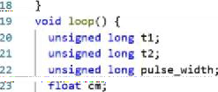TneMeasuredDistanceincm:197.00

TheMeasuredDistanceincm:2.00Alert!!



ENG

12£9

@lJ\zoS//wokWj.cOm/|›rojectS/.34674346902421fi636









ee



TheMeasuredDistanceincm:Z.00Alert!!



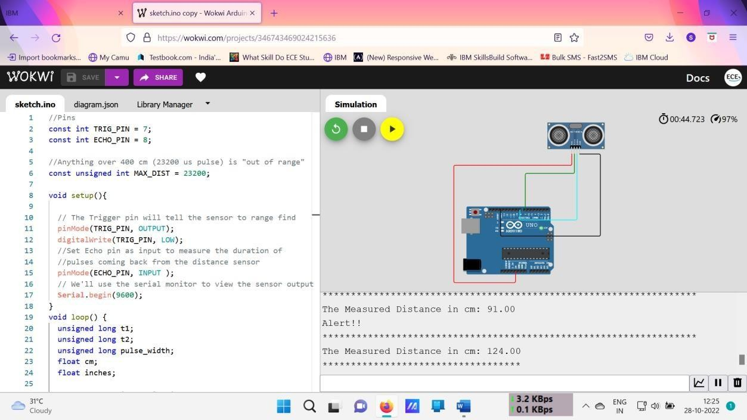

Link:<https://wokwi.com/projects/346743469024215636>